606 Fairgrounds Rd.

Warrenton, MO 63383

Administration| 636.456.8935

Fax| 636.456.7764

[www.warrenton-fire.org](http://www.warrenton-fire.org)

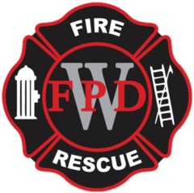

Warrenton Fire Protection District

**NOTICE OF MEETING**

Public notice is hereby given that a meeting of the Board of Directors of the Warrenton Fire Protection District will be held at - **Fire Station No. 2, 26625 S. Highway 47 Warrenton, MO**, Warrenton, Missouri, on Tuesday, August 19, 2025, at 7:00 p.m. to consider and act upon the matters on the following agenda and such other matters as may be presented at the meeting and determined to be appropriate at that time.

**AGENDA**

1. Open Meeting
2. Pledge of Allegiance
3. Approval of Agenda
4. Approval of Previous Minutes
5. Approval of Payment of Bills
6. Review of Treasurer’s Report
7. Financial Report- Presented by Rick Rognan
8. Public Comments
9. Old Business
   1. Payment to Board of Directors
10. New Business
    1. Architect Contract
    2. Present preliminary budgets for 2026
    3. Review Stifel Capital Investment Report
    4. Resolution 2025-06 Tax Rates
11. Committee Reports

Building & Grounds

Water Softener

Garage door openers

Station furniture/table

Equipment & Maintenance

Community Outreach

Planning

Membership

1. IAFF Report
2. Fire Marshal Report
3. Chief’s Report
4. Adjournment

The tentative agenda of this meeting may also include a vote to close part of this meeting to the extent it relates to the following: Pursuant to Section(s) 610.021(1-24).

Dated August 15th, 2025

**Rob Vogelgesang**

Rob Vogelgesang, President – Board of Directors