606 Fairgrounds Rd.

Warrenton, MO 63383

Administration| 636.456.8935

Fax| 636.456.7764

[www.warrenton-fire.org](http://www.warrenton-fire.org)

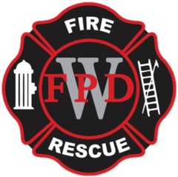

Warrenton Fire Protection District

**NOTICE OF MEETING**

Public notice is hereby given that a meeting of the Board of Directors of the Warrenton Fire Protection District will be held at - **Fire Station No. 2, 26625 S. Highway 47 Warrenton, MO**, Warrenton, Missouri, on Tuesday, June 17, 2025, at 7:00 p.m. to consider and act upon the matters on the following agenda and such other matters as may be presented at the meeting and determined to be appropriate at that time.

**AGENDA**

1. Open Meeting
2. Pledge of Allegiance
3. Approval of Agenda
4. Approval of Previous Minutes
5. Approval of Payment of Bills
6. Review of Treasurer’s Report
7. Financial Report- Presented by Rick Rognan
8. Public Comments
9. Old Business
   1. Bond 2025 Update
10. New Business
    1. SB 870 Resolution – Setting a 100% Reimbursement Rate for property taxes of every type for the purposes of providing emergency services as authorized under three separate Missouri statutes
    2. MFA Fuel Contract
11. Committee Reports

Building & Grounds

Equipment & Maintenance

Community Outreach

Planning

Membership

1. IAFF Report
2. Fire Marshal Report
3. Chief’s Report
4. Adjournment

The tentative agenda of this meeting may also include a vote to close part of this meeting to the extent it relates to the following: Pursuant to Section(s) 610.021(1-24).

Dated June 13th, 2025

**Rob Vogelgesang**

Rob Vogelgesang, President – Board of Directors